Project Design Phase – I ARCHITECTURE

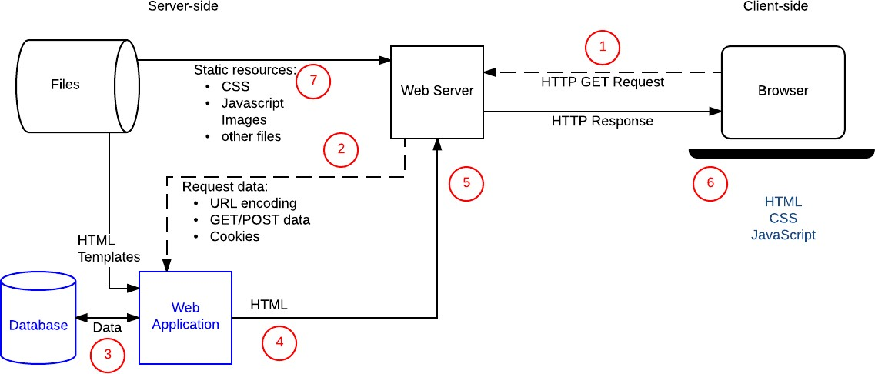

|  |  |
| --- | --- |
| Date | 03 October 2022 |
| Team ID | PNT2022TMID47367 |
| Project Name | Project - customer care registry |
| Maximum Marks |  |

**TECHNICAL ARCHITECTURE**

